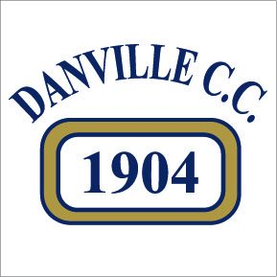 DANVILLE COUNTRY CLUB
2718 Denmark Rd. • Danville, Il 61834 • Phone (217) 442-5213
Email • Info@golfdanvillecc.com
Facebook • Danville Country Club
Instagram • danvillecountryclubil

Located in East-Central Illinois
Private, member-Owned, 100-year old Country Club.
150-acres, 18-holes with bentgrass/Poa annua greens and fairways. Bentgrass and Zoysia tees.
1 irrigation lake, 1 pond, 3 clay tennis courts, and clubhouse landscaping.
Bentgrass/Poa practice tee and range
Turf nurseries
>600-head Toro OSMAC irrigation system with Toro Lynx software.

Skills desired:
Ability to diagnose/anticipate pests and prescribe cultural and chemical controls.
Knowledge of plant nutrition analysis.
Pesticide and Fertilizer applications, calibrate spraying and spreading equipment.
Irrigation system programing, plumbing and electrical repairs on irrigation system.
Hire/Train/Supervise/Schedule staff of up to 10 employees (most are seasonal)
Maintain clay tennis courts daily: water, roll, brush etc.
Responsible for ordering of all chemical products and components for repair of irrigation and equipment.
No water restrictions or water limitations, surface fed lake on property provides irrigation water with back-up well.
Position requires exceptional eye for detail.

Desired Education and Experience:
- 2-year Assoc. degree or certificate in Golf Course / Turf Management
- 4-years experience in golf course management as Supt. or Asst. Supt.

Position reports to General Manager
Must obtain IL Pesticide Applicator License -Turf Category from IL Dept. of Agriculture
Salary range: Commensurate on Experience
Benefits Package: 60/40 Family Health Insurance Split, 3% IRA Match
Allowance for Continuing Education

