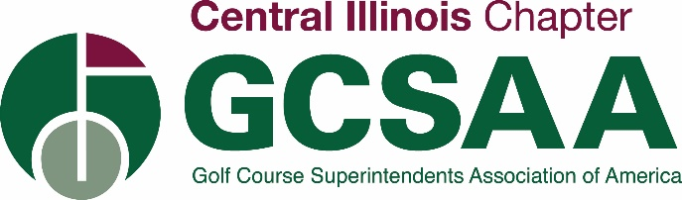

2022 CIGCSA STAFF DEVELOPMENT
TURFGRASS CERTIFICATE/HOUSING REIMBURSEMENT

INFORMATION FOR APPLICANTS

The CIGCSA/James W. Brandt Scholarship fund offers educational aid to the children, grandchildren, and dependents of the CIGCSA. Due to strategic planning and proper stewardship of the fund account, CIGCSA is fortunate to offer an additional professional growth award. The award will provide funds to current CIGCSA Class A, B, C, and EM members to continue their education and enhance their careers in Turf Management.

CIGCSA/James W. Brandt Scholarship fund will award one (1) applicant a reimbursement on the cost of tuition and housing for a short course certificate up to $2,000.00.

For a member to be eligible for a CIGCSA/James W. Brandt Award, the following requirements must be met:

- Applicant must be a Class A, B, C, or EM member in good standing with CIGCSA.

Applicants who satisfy these requirements will compete based on their overall qualifications for the CIGCSA/James W. Brandt Staff Development Award. Selection will be determined by the Scholarship Committee and the approval by the Board of Directors based on an evaluation of the following criteria:

- The applicant’s demonstration of a desire to further their career in Turf Management, as well as a broad base of interests and accomplishments, including historical participation in CIGCSA events.

- A short essay composition by the applicant (500 – 750 typed words) describing why they feel they would be a qualified recipient of the CIGCSA/James W. Brandt Staff Development Award.

ALL MATERIALS MUST BE RECEIVED AT CIGCSA NO LATER THAN
NOVEMBER 15th, 2022

SEND TO:
CIGCSA

PO Box 3684
Bloomington, IL 61702-3684

